Chapter 5 Crossword

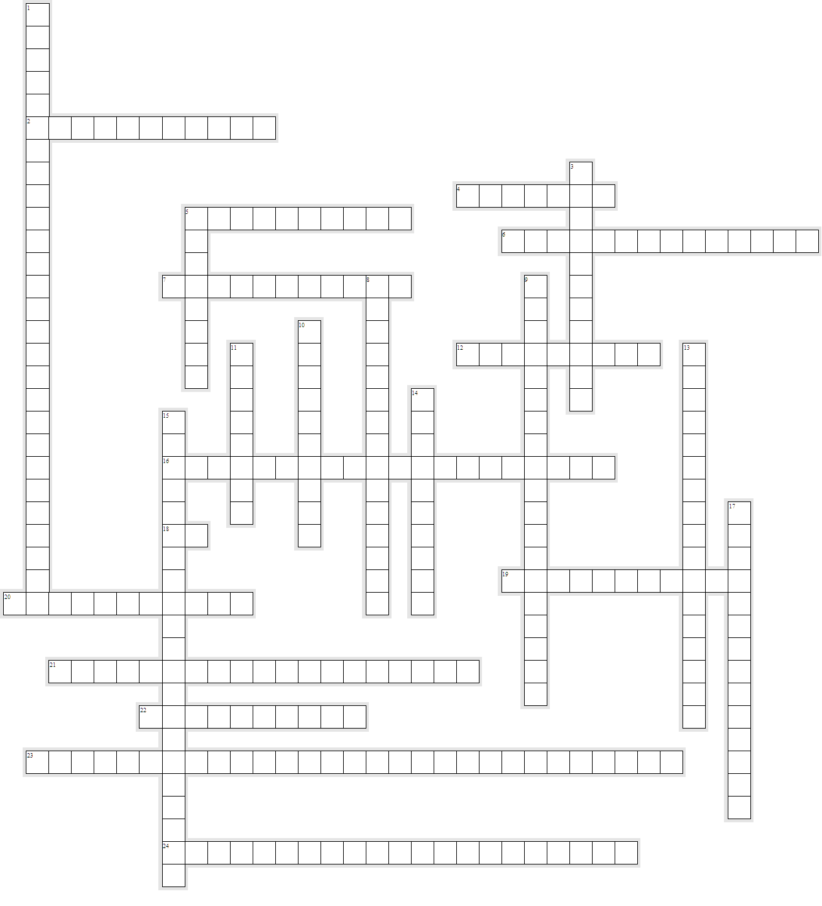

Across

2. Action on a whim without consideration of the consequences.
4. The idea that some people are born before progressing through all the evolutionary stages to become fully human.
5. No reaction to a behavior.
6. The search for the causes of antisocial behavior within the brain or body.
7. A perspective stating that environment and learning determine how individuals behave.
12. The act of thinking and perceiving.
16. The idea that people learn how to act by watching others and copying the interactions that are rewarded and avoiding those that are punished.
18. A measure of intelligence taken by dividing a person’s mental age by chronological age, then multiplying by 100.
19. The practice of determining a person’s character by facial characteristics.
20. A condition that occurs when males receive an extra copy of the Y chromosome.
21. A form of learning based on the positive or negative consequences of an action, behavior, or activity.
22. The practice of determining a person’s character by the shape of the body.
23. A mental disorder characterized by a pattern of disregard for the rights of others, as well as impulsive, violent, and aggressive behavior without guilt.
24. Ending an undesirable consequence as a means of reward.

Down

1. Generally, the acquittal of a defendant because he or she is determined to be insane.
3. A mental disorder that involves a severe lack of empathy.
5. The concept that human beings can degenerate or improve through breeding.
8. The idea that public welfare of any sort only helped the unfit survive to weaken society.
9. The study of memory, language processing, perception, problem solving, thinking, and other mental processes.
10. The practice of determining a person’s character and mental faculties by measuring bumps and other features of an individual’s skull.
11. The biological process in which genetic characteristics are inherited by one generation from the last.
13. The idea that biological forms change over time through genetic inheritance.
14. An approach that places emphasis on observable facts.
15. Rewarding a successful action.
17. The idea that the shape of the body directly predicts the propensity for criminal offending.

