Chapter 13 Crossword

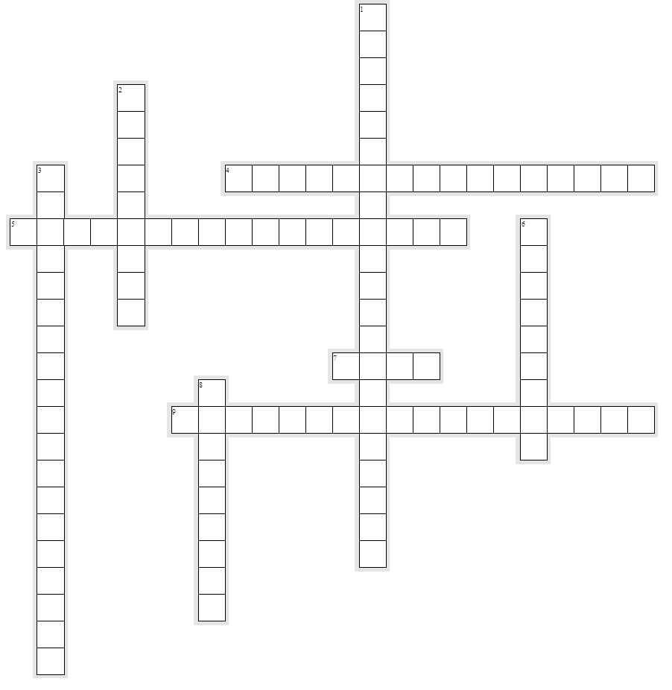

Across

4. A criminal offense that occurs as part of another criminal offense or complex of offenses.
5. A term referring to the intersections of two or more social categorizations such as race, class, color, gender, age, and sex and the added challenges of discrimination faced by individuals at those intersections.
7. Hostile feelings or opinions, usually unreasonable, about a social group or class.
9. A method proposed by Jeremy Bentham in which criminal offenders calculate the worth of breaking the law by estimating the positive consequences versus the possible negative consequences.

Down

1. The idea that people who experience anger and frustration when they cannot achieve cultural goals through legitimate means try to achieve these goals through illegitimate means.
2. A criminal offense like murder or rape, but with an added element of bias.
3. Agnew’s revision of classical strain theory identifies three major types of strain: failure to achieve goals, the loss of positive stimuli, and the gain of negative stimuli.
6. A disparaging opinion that is not based on logic or actual experience with the subject of the disparagement.
8. Violence perpetrated against civilians by political groups for the purpose of drawing attention to their cause.

