Chapter 1 Crossword

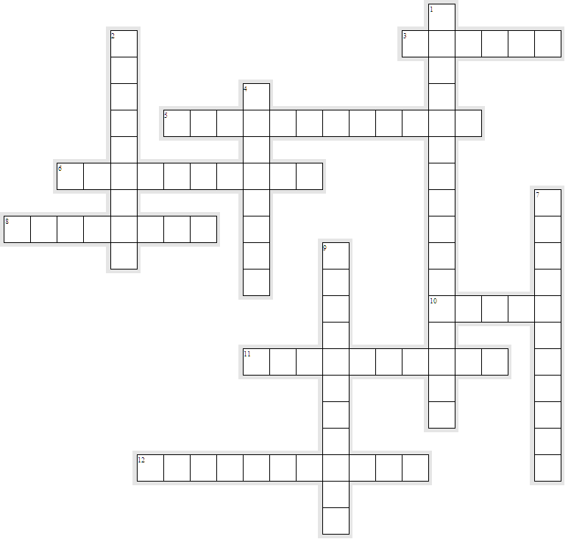

Across

3. A statement or set of statements that explains a concept and that has withstood repeated tests and can be used to make inferences about other concepts.
5. The killing of a sequence of victims committed in three or more separate events over an extended period of time.
6. Repeat offending.
8. Behaviors that violate cultural norms, rules, or laws.
10. Behavior that is prohibited by laws and has prescribed punishments.
11. Following standards of behavior intended to harm society and individuals.
12. The study of the making of laws, the breaking of laws, and the social reaction to the breaking of laws.

Down

1. Financially motivated criminal offenses committed by way of deceit and without violence, usually involving the offender’s place of employment or business.
2. Following standards of behavior intended to facilitate society and individuals.
4. Law that is related to private rights and disputes between citizens.
7. Materially destructive or violent criminal offenses that are often interpersonal and represent those for which the police are most often called.
9. Law that deals with the prosecution and definition of crime.

