Instructor’s Resource Manual
SAMPLE
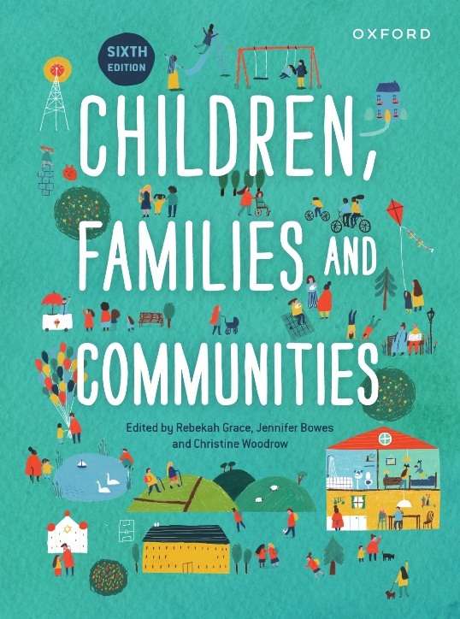 | Children, Families and Communities  Sixth Edition  Edited by Rebekah Grace, Jennifer Bowes and Christine Woodrow  IRM prepared by Deborah Bennetts
COPYRIGHT NOTICE
This instructor’s resource manual is copyright Oxford University Press 2023. It is intended for use only by lecturers prescribing Children, Families and Communities, sixth edition, in their courses and should not be distributed or copied for any other purpose or for use with any other text.

Contents
1 Understanding the child in context: An ecological approach to child development 3
2 Research about and with children, families and communities 8
3 Gender identity in early childhood 12
4 Children with disability: Rights, risks and opportunities 15
5 Child mental health 21
6 Refugee children: Supporting refugee families in transitions 25
7 Family as the primary context of children’s development 29
8 Children’s friendships 33
9 Children thriving and learning in a digital world 37
10 Interconnections among family, childcare and education 41
11 Social inequities in Australian communities and the impact on children and families 45
12 Child protection and out-of-home care 49
13 The Stolen Generations of Aboriginal and Torres Strait Islander Children:
Understanding the impact of cultural hegemony in policy and intervention 52
14 Climate change and disasters 56
15 Early childhood education and care policy in Australia 60
16 Services working together to support children and their families 64
17 Approaches to policy and practice to support children, families and communities 68

1 Understanding the child in context: An ecological approach to child development
Rebekah Grace, Cris Townley and Chris Woodrow

Ice Breakers
- In table groups (or break out rooms), share your thinking around ‘Nature vs Nurture’. Try to give an example from your own life to back up your thinking.
- Prepare a word cloud template by going to Mentimeter.com. Add a new Menti question: ‘What words do you think of when you hear the name “Bronfenbrenner”?’.
Use the resulting word cloud to stimulate discussion and debate from/between students.
- Ask students what they think about the most often used word or term (largest in display). Do they agree/disagree?
- Are there words they see in the word cloud that they think should have been more important? What words and why?
NB: A Mentimeter account is free. Students log in on laptops, phones or iPads. Set a 1–3-minute time limit for contributions (they are anonymous).

Group Activities
- As a tutorial watch https://www.youtube.com/watch?v=n7VMo51xRTA
Ask students to form groups of 4 (or break out rooms of 4).
- Refer students to Figure 1.1, p. 4
- Ask students to use the model from the video to track the impact of each of Bronfenbrenner’s systems on them being in this university tutorial today.
- Which systems had the most influence? How have the systems worked together?
- Ask each student to share their thinking with their group.
Can the students see similarities on the impact of systems in their group? Or has each student had different systems impacting them in different ways?

- Neuroscience and Brain Development, p. 6.
As a tutorial watch https://www.youtube.com/watch?v=VNNsN9IJkws&t=16s and https://www.youtube.com/watch?v=m_5u8-QSh6A
Chapter 1 discusses the ‘proximal processes’ which take place in the microsystem,
p. 7.
Ask students to consider:
- The importance of relationships and attachment to children’s development
- How strong mutual attachment can be a protective factor for a child.
- Investigate programs or services in your local community that support attachment between child and parent/s.
- What are some other, less formal ways that parent and child attachment can be supported within a family and community?
- ‘We argue that complex environments are not necessarily chaotic and may, in fact, support positive child outcomes, particularly as this relates to the acceptance of diversity, the empowerment of women, and opportunities for children and young people to actively participate in civil discourse’, p. 12.
- In small groups, ask students to read this section of the chapter and consider this statement.
- In what ways do they see chaos as being evident in life today?
- In what ways might chaos have a negative impact on children?
- What ways can you see our changing environment not as ‘chaos’, but as supporting positive child outcomes? Ask students to share examples they have lived or observed.
- As a tutorial watch https://www.youtube.com/watch?v=pbu_vtJfF60&t=498s (watch the first 5 minutes) and ask groups to navigate to https://vermontpsychology.org/2020/05/13/anne-koplinka-loehr-effects-of-the-covid-19-pandemic-on-families-in-windham-county-vermont/
- In small groups, consider the ways COVID-19 has impacted families across multiple ‘systems’.
- What systems have been impacting families due to the pandemic?
- Have these had direct or indirect impacts on families?
- What supports have you seen being put in place in your community to ameliorate these impacts?

Research Activities
- See Box 1.4, p. 9, ‘The influence of culture on proximal processes’.
Chapter 1 discusses a possible criticism of Bronfenbrenner’s model—‘not capturing well the experiences of children and families in a multicultural society’, p. 9.
In pairs, read Rocco’s story and discuss the impact of culture in his life.
- The impact of his Nonno’s culture in his life.
- The impact of his teacher’s culture in his life.
- The impact of his peer’s culture in his life.
- As a tutorial watch https://www.youtube.com/watch?v=oLgT2qutf_A (for education students) or https://www.childrens.health.qld.gov.au/qhlfss-miplabinna-working-with-atsi-families/ (video 1 ‘Mipla Binna – Closing the Gap Aboriginal and Torres Strait Islander Health’) or https://www.youtube.com/watch?v=iOFuRbbsfuM (for health services students).
Introduce a discussion to get students thinking about the dominant culture they see in Australia. Chapter 1 talks about the impact of Australia’s dominant culture ‘Anglo-centric whiteness’, p. 9. Lead a discussion on the evidence students see or have experienced that this is our dominant culture.
In pairs, research the impact of Australia’s dominant culture ‘Anglo-centric whiteness’, p. 9, on Indigenous children and families or on a cultural group of the student’s own choosing.
Students might consider:
- Indigenous families (or other cultural group) and their engagement with early childhood education and care services or with health services
- barriers to engagement
- ways to engage in culturally appropriate ways
- critical reflection around our dominant culture.
Some resources to use in this research are:
https://education.nsw.gov.au/content/dam/main-education/early-childhood-education/operating-an-early-childhood-education-service/media/documents/making-services-accessible-for-all-children/aboriginal-childrens-early-childhood-education-strategy.pdf
https://research-management.mq.edu.au/ws/portalfiles/portal/16770396/mq-19168-Publisher+version+%28open+access%29.pdf
https://www.aecg.nsw.edu.au/about/partnership-agreement/
https://www.youtube.com/watch?v=UdaeoKT_ECU
https://www.youtube.com/watch?v=19buRXzJtyU
https://www.creativespirits.info/aboriginalculture/health/hospitals-doctors-health-aboriginal-people
https://headspace.org.au/yarn-safe/the-yarn-safe-story/

Case Study Analysis
- See Box 1.5, p. 11, ‘The role of time in learning’.
In small groups of 3–4 (or break out rooms), ask students to consider Holly’s case study.
Discuss:
- What is the impact on Holly of the attachment between Holly and her mother?
- What part does the preschool teacher play in Holly’s story? Is the teacher’s role important in Holly’s development? What system is the preschool operating within?
- What evidence is there that time played an important role in the development of Holly’s social skills?
For health students, using Holly’s story, consider the importance of attachment and family partnerships in the health system.
- What system does the health services sector operate within?
- What is the impact of time in developing relationships with families?
Some links to consider:
https://www.rch.org.au/uploadedFiles/Main/Content/ccch/150130_Using-the-Family-Partnership-Model-to-engage-communities_Report.pdf
https://gwahs.net.au/australian-nurse-family-partnership-program
For education students, watch as a tutorial https://www.youtube.com/watch?v=e4tbW3XJfAY&t=56s
This video discusses things that parents can do to establish an early learning partnership, but what can, and should, educators be doing to establish this strong partnership?
For health sciences students, watch as a tutorial https://www.youtube.com/watch?v=rxiswGvZxZQ&feature=emb_imp_woyt
What can health professional do to establish strong partnerships with families?

