**Web article 22**

# John Spencer, University of Greenwich

**Case study on Maraviroc, a CCR5 Antagonist for HIV Treatment**

**Introduction**

Maraviroc, a recently marketed Pfizer drug for HIV treatment, is an excellent representation of a drug developed employing a *fail fast fail cheap* strategy whereby its target (CCR5)

affinity was improved whilst reducing unwanted side effects.1 It is pointless and

uneconomical (and easily said in hindsight!) to spend hundreds of millions of pounds in developing a drug only to see that it fails clinical trials due to a side effect that could have been eliminated or “red lighted” during the (cheaper) drug discovery stage. In this article, we will present a case study on the development of maraviroc, the

elimination of unwanted off-target HERG affinity2 and

currently developed second generation molecules. An initial introduction to familiarise the reader with the CCR5 receptor and the importance of eliminating HERG in drug development will be presented.

**The CCR5 Receptor** is a GPCR, which is actively involved in the HIV cycle acting as a co-receptor to the CD4 receptor and gp120 on the cell surface before viral entry. CCR5 antagonists have been actively sought to combat HIV infection.

**HERG ion channel**, the human ether-a-go-go related gene!!! (K+ channel) is associated with long QT Syndrome, torsades de pointes, arrhythmia and sudden cardiac death. A number of drugs have been withdrawn from the market due to HERG problems, including terfenadine,



an antihistamine. Curiously, terfenadine is not an active H1 receptor antagonist; it is a *prodrug* of fexofenadine via metabolism by CYP3A4. Contraindications include grapefruit juice or other medications which are known to inhibit the metabolic cytochrome P450enzyme, CYP3A4. The high levels of terfenadine that result from blocked metabolism can lead to cardiotoxicity, due to the ability of terfenadine to block the HERG ion channel in cardiac muscle. As a result, terfenadine was withdrawn from the market and replaced by fexofenadine (its active metabolite).

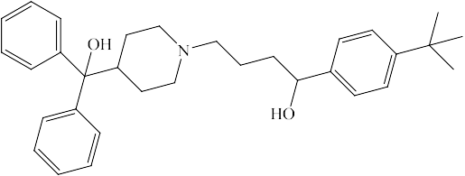

# Metabolism of terfenadine (left) to fexofenadine (right).

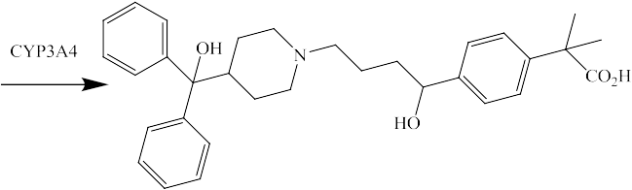

Cisapride and dofetilide are further examples of agents that suffer serious side effects as a result of blocking the HERG channel. The former has since been withdrawn from the market as a prokinetic agent (5HT4 agonist) and the latter is only used under strict medical supervision for treating atrial fibrillation. Isotopically labelled (3H) dofetilide is used as a displaceable ligand in high throughput binding assays for HERG activity.

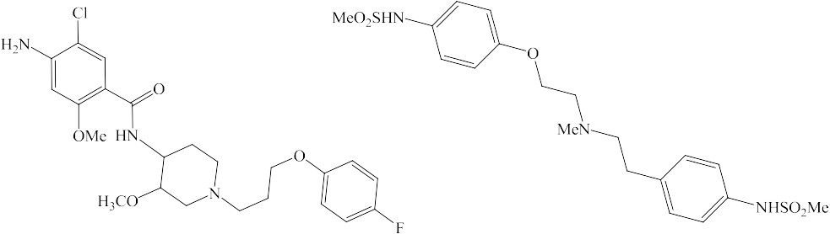

Therefore, given the unwanted cardiotoxicity associated with HERG channel blockage, factoring out HERG activity in molecules during the drug discovery process is an important approach employed by many pharmaceutical companies.

# Development of maraviroc

In the search for a small molecule CCR5 antagonist, scientists at Pfizer started with the rather complicated lead molecule **1**, consisting (from left to right) of a cyclobutane carboxamide linked via an alkyl spacer to tropane and benzimidazole rings. However, **1** displayed high affinity towards the HERG channel and so analogues were synthesised with the aim of eliminating such undesirable affinity whilst improving CCR5 affinity.3

Several approaches were employed, to look at the SAR (structure activity relationship) by modifying:

1. the basicity of the central (tropane) nitrogen
2. the substitution pattern of the aromatic ring of the benzimidazole
3. the lipophilicity of the molecule
4. the basicity of the cyclobutyl carboxamide group

Approach i)

One reason for modifying the tropane ring system was to investigate whether the basicity of the tropane nitrogen played a role in affinity towards the CCR5 receptor or HERG ion channel. One analogue which was synthesised was structure 2, containing an oxygen bridgehead. Although the basicity of the central nitrogen was significantly reduced (pKa=7.8 for **1** vs. 6.0 for **2**), the affinity of both compounds towards HERG was similar, suggesting that the basicity of the central nitrogen atom has little effect on HERG affinity.

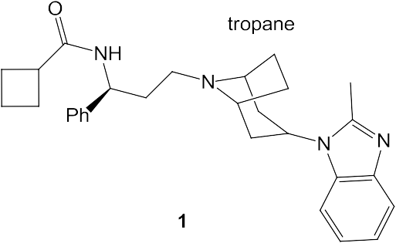

Approaches ii) and iii)

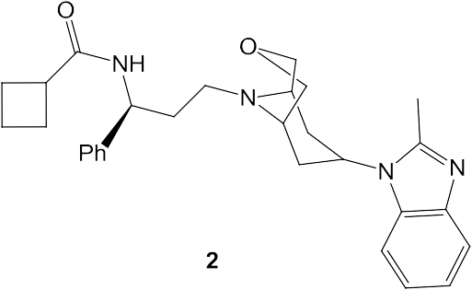

Removal of the fused aromatic ring in **1**, as in the synthesis of **3** and **4,** led to very good antiviral activity and low HERG affinity. The drop in HERG affinity could be rationalised from molecular modelling experiments where structure **1** was docked into the binding site of a HERG model. These suggested that there was a good overlay of the aromatic ring of the benzimidazole ring in structure **1** with a lipophilic region of the HERG channel. Therefore, removing the aromatic ring removed this interaction and lowered affinity.

Approach iv)

Structure 4 was now established as the new lead compound. The molecular modelling experiments described above had also shown that there was a favourable hydrophobic interaction between the cyclobutyl carboxamide group of structure **1** and the HERG channel. Therefore, the next tactic was to disrupt this interaction. Changing the ring size in **4** from a four membered cyclobutane unit to a cyclopentane unit (structure 5), termed a homologation,

led to a significant increase in antiviral potency and loss of HERG affinity. The loss of HERG affinity was due presumably to the larger cyclopentyl ring having unfavourable steric interactions with the binding site of the HERG ion channel. In contrast, the fluorinated analogue **6** had both reduced antiviral potency and HERG affinity.

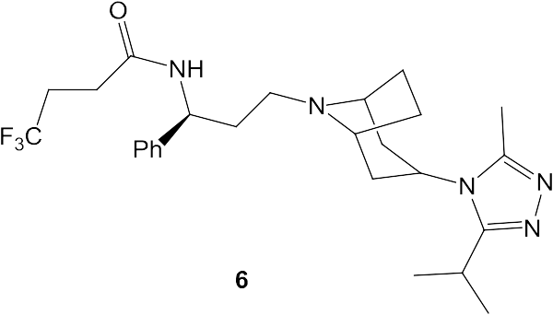

Further modification of **6** led, eventually, to maraviroc **7**, containing a *gem*- difluorocyclohexyl group. Maraviroc retained excellent antiviral activity at the nanomolar level, whilst exhibiting no significant HERG binding affinity. The lack of HERG binding affinity was due to the large size of the cyclohexyl group and the high polarity of the fluoro substituents. Both factors disfavoured binding to a lipophilic region of the HERG channel, a result that had been predicted through molecular modelling.

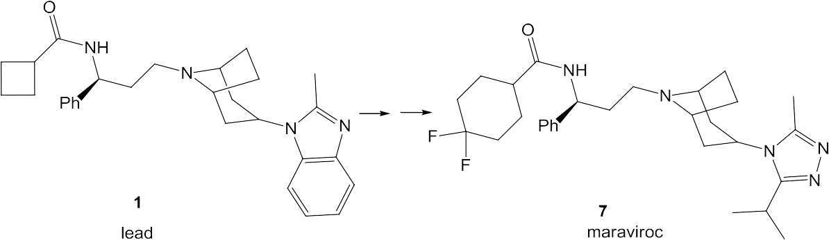

The next generation of CCR5 antagonists are now being developed, including the maraviroc- like **8**.4,5 The aims are to improve biological properties, and to overcome probable drug resistance where the virus may make use of the CXCR4 receptor for viral entry rather than the (antagonised/blocked) CCR5 receptor.

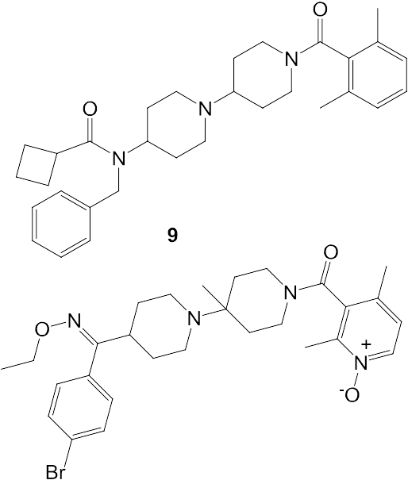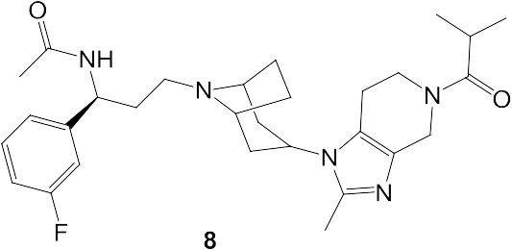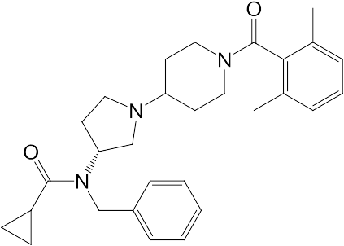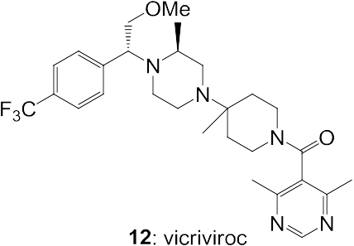

Vicriviroc **12**, like maraviroc, is a CCR5 antagonist. It acts as an allosteric modulator, creating a conformational change in CCR5, preventing binding of gp120 to the target cell, thus thwarting HIV viral entry into the cell. Structure **12** was designed from a previously investigated molecule **11**, which had significant HERG affinity. Both structures **11** and **12** contain a somewhat ubiquitous (privileged) piperidine motif which is also present in other structures under study, such as **9** and **10**.

# Conclusion

CCR5 antagonists remain an important class of drugs for HIV treatment. Their design has involved a balancing act, pitting desirable antiviral potency vs. undesirable HERG affinity.

An array of new generation antivirals are now being developed with even better properties

* 1. oral bioavailability and longer onset of action.

# References

* + 1. D. Kuritzkes et al. *Nature Rev. Drug Disc*. 2008, **17**, 15-16.
    2. M. J. Killeen, *Drug Disc. Today*, 2009, 589-597.
    3. D.A. Price et al. Bioorg. *Med. Chem. Let*t. 2006, **16**, 4633-4637.
    4. D. C. Pryde et al. Bioorg. *Med. Chem. Lett*. 2009, **19**, 1084-1088.
    5. A. Hall *Future Med. Chem*. 2009, **1**, 431-434.
    6. Strizki, J.M. et al. *Antimicrob. Agents Chemther*. 2005, 4911-4919.