Chapter 42

Pedagogy for Teaching Baritone/Tuba

**Supplemental Figures**

Jennifer Jester

Fig. 42.1 - Baritone with incorrect posture slumped 1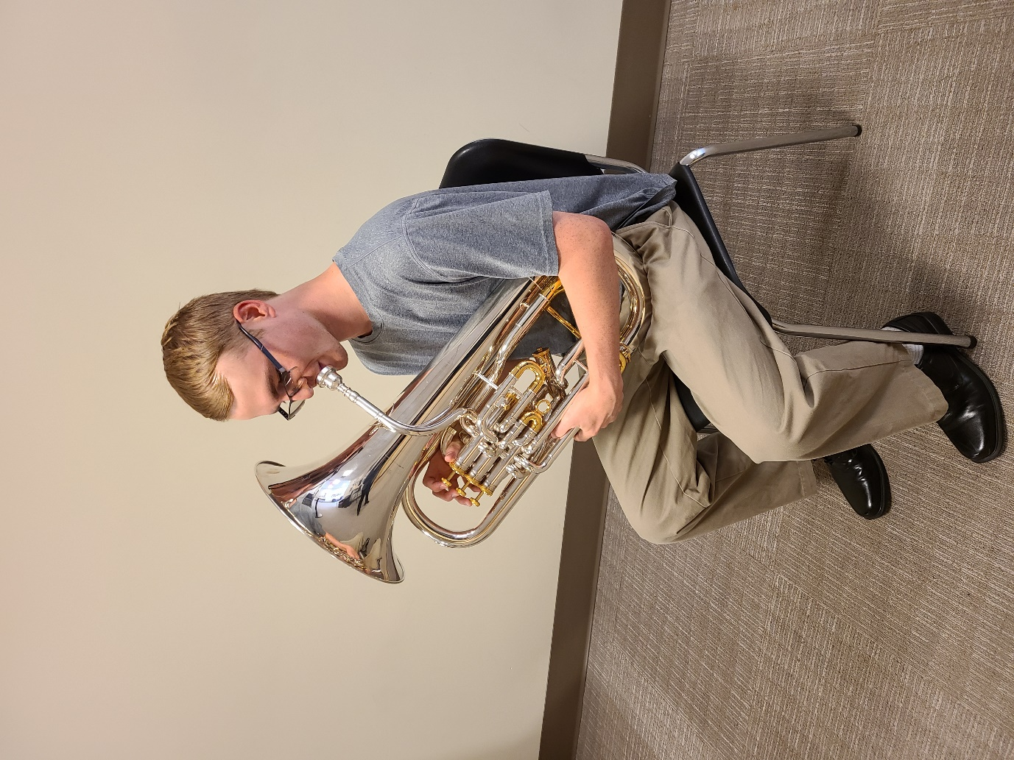

Fig. 42.2 - Baritone with incorrect posture twisted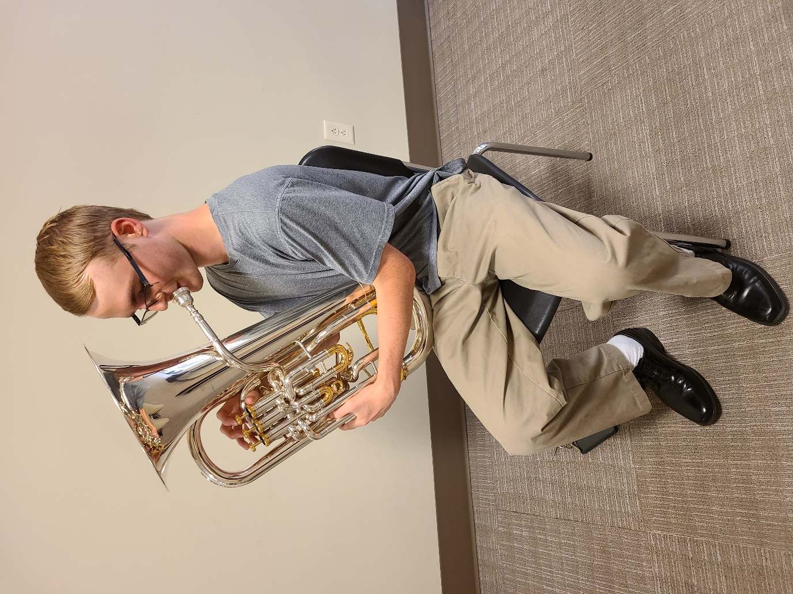

Fig. 42.3 - Baritone with incorrect posture on wrong knee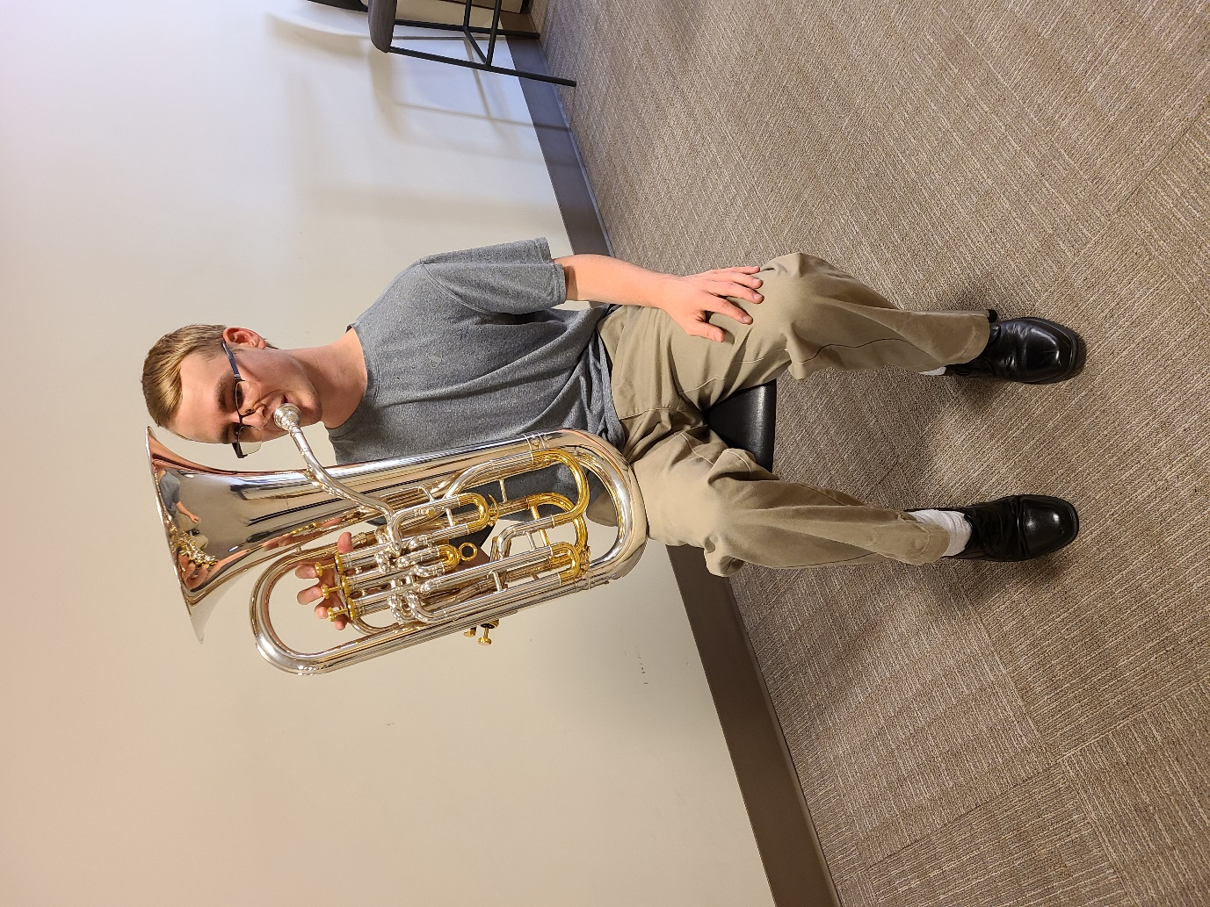

Fig. 42.4 - Baritone with pillow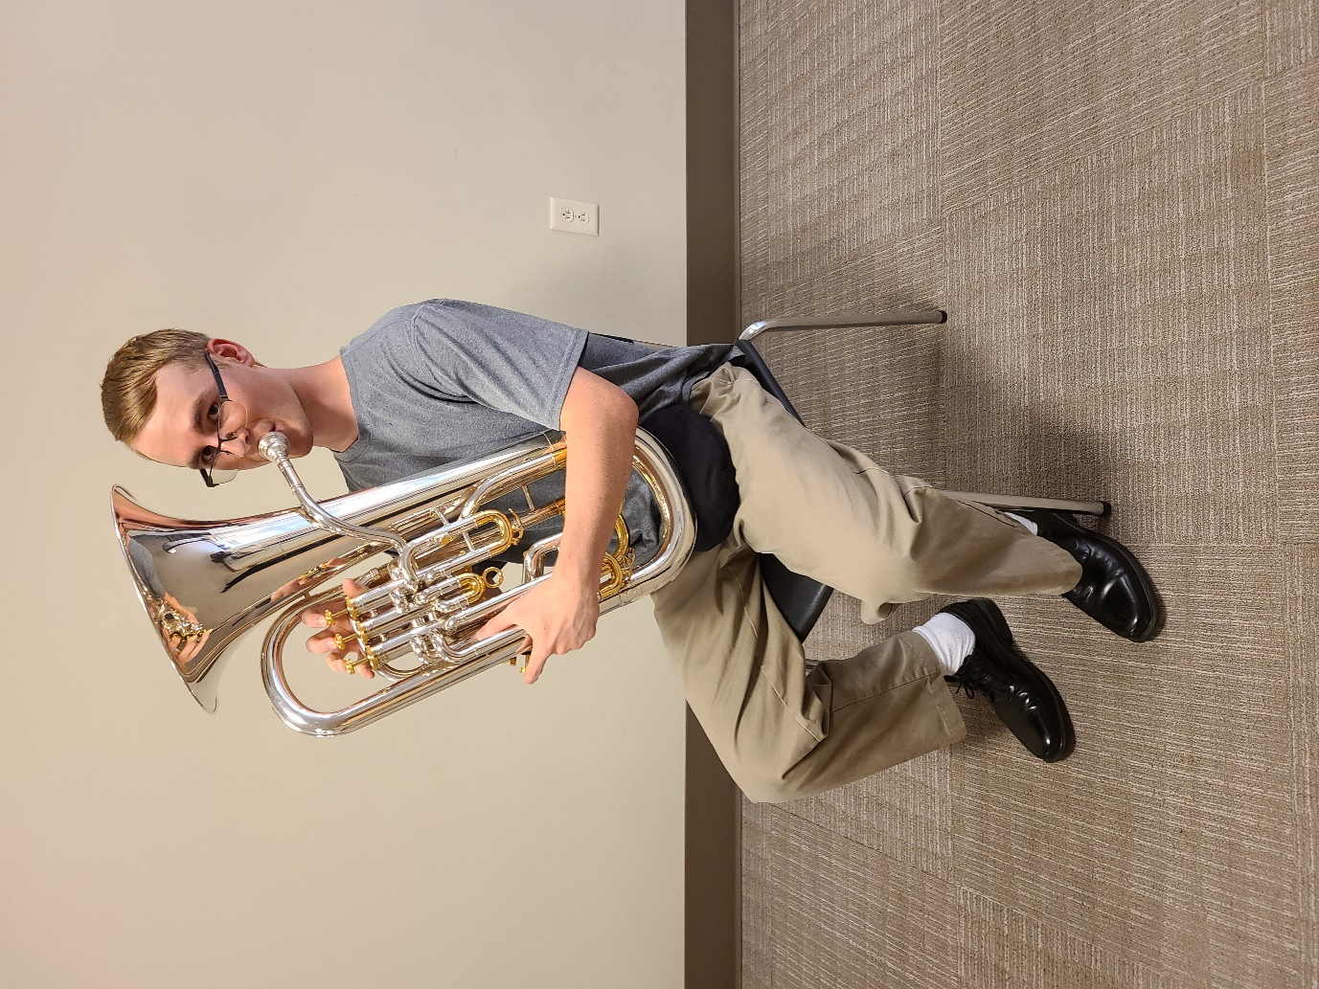

Fig. 42.5 - Baritone with pillow closeup 1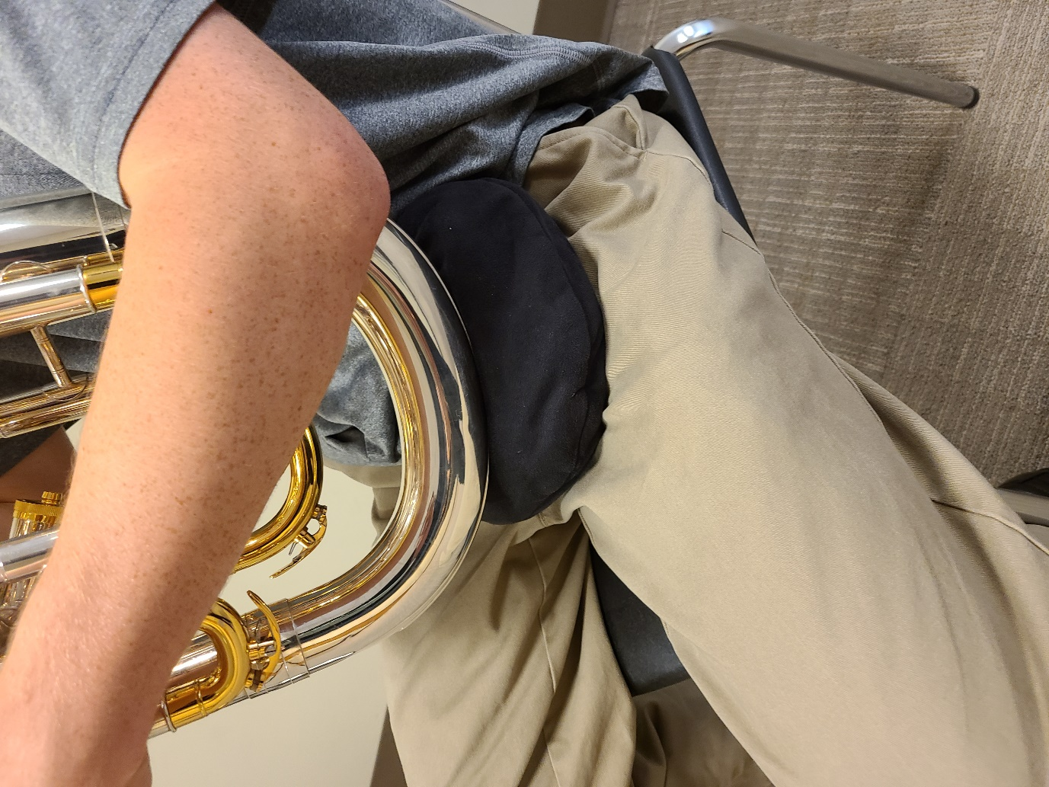

Fig. 42.6 - Baritone with hand strap 1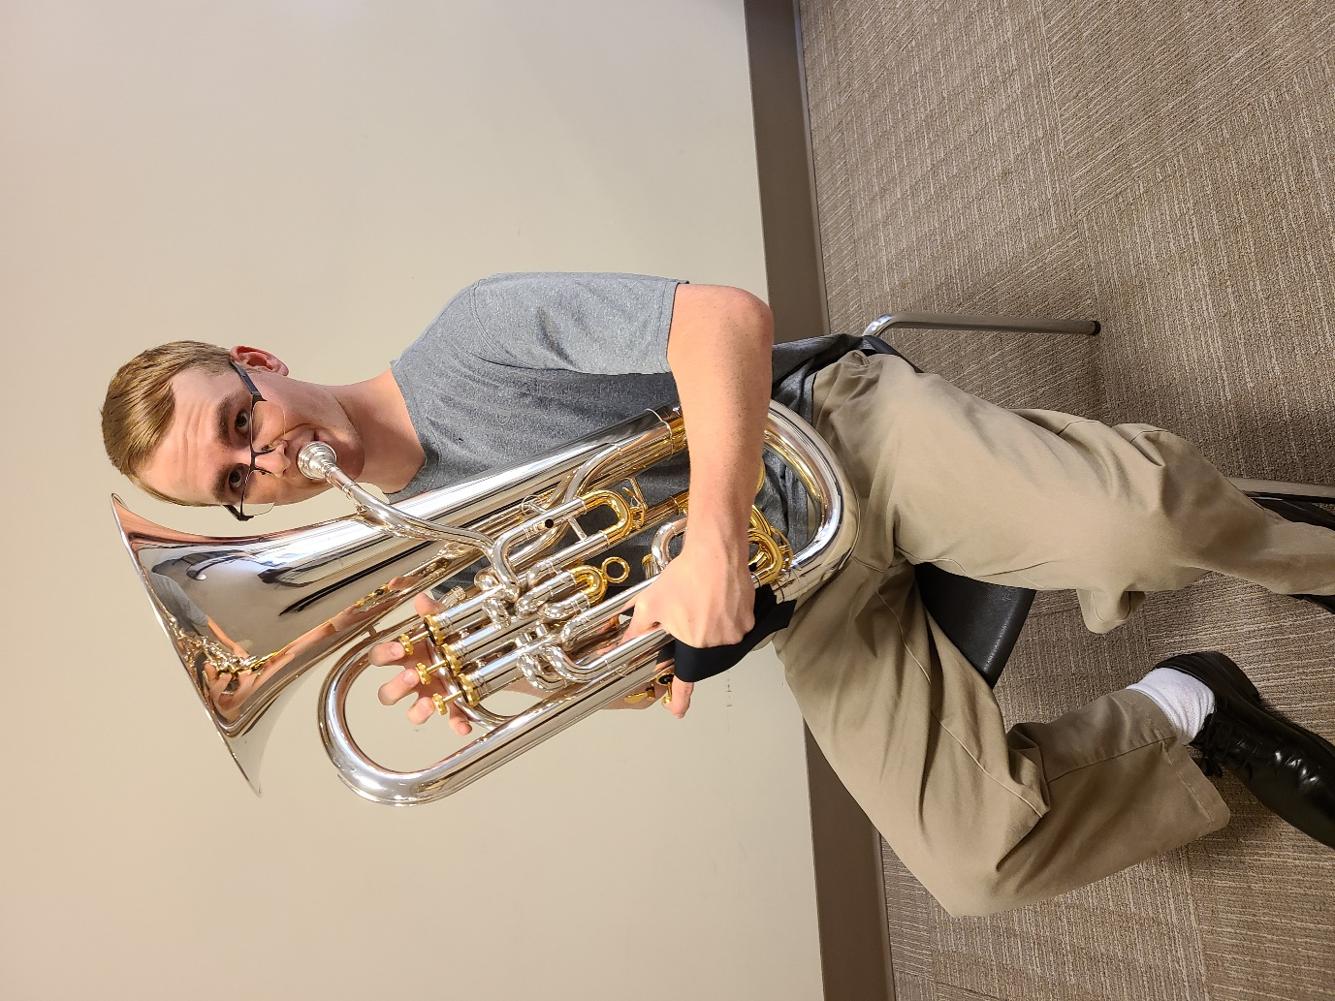

Fig. 42.7 - Baritone with hand strap 2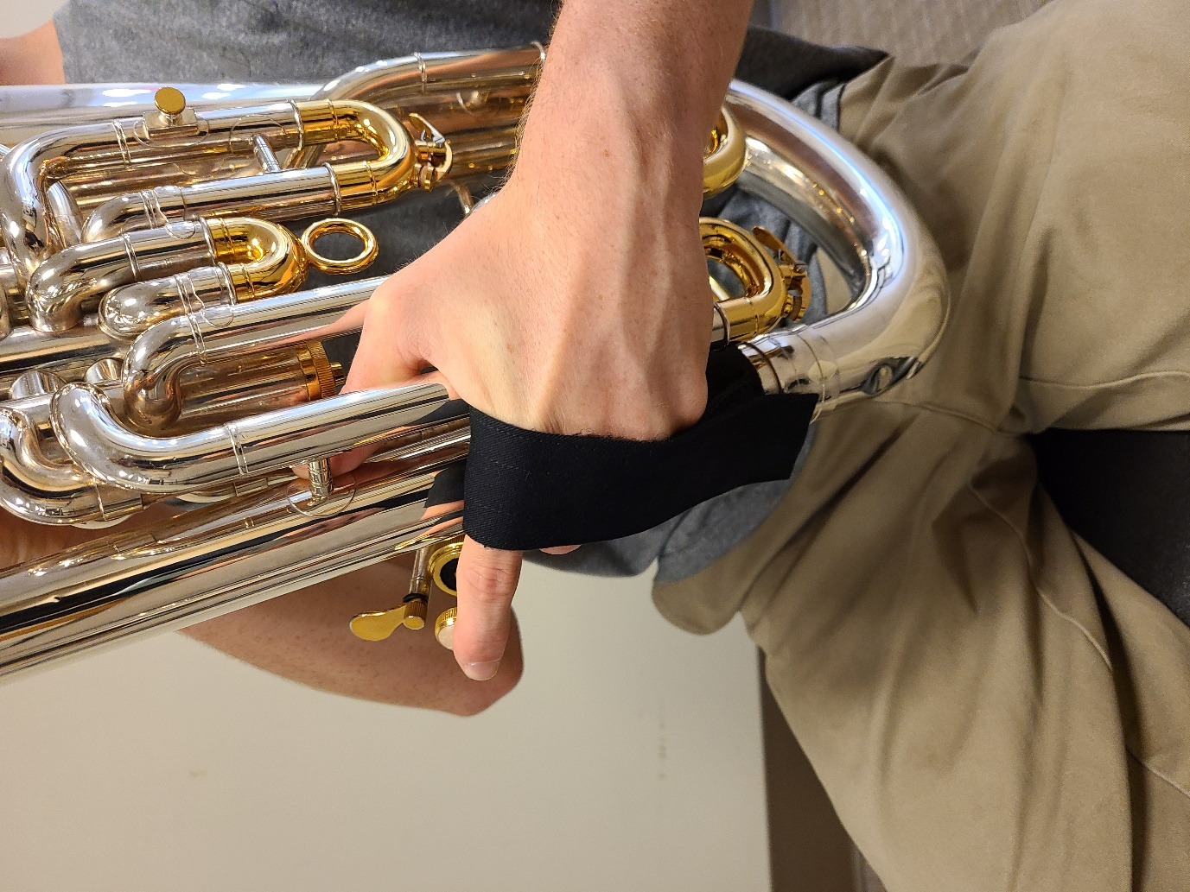

Fig. 42.8 - Second tuba with stand 2

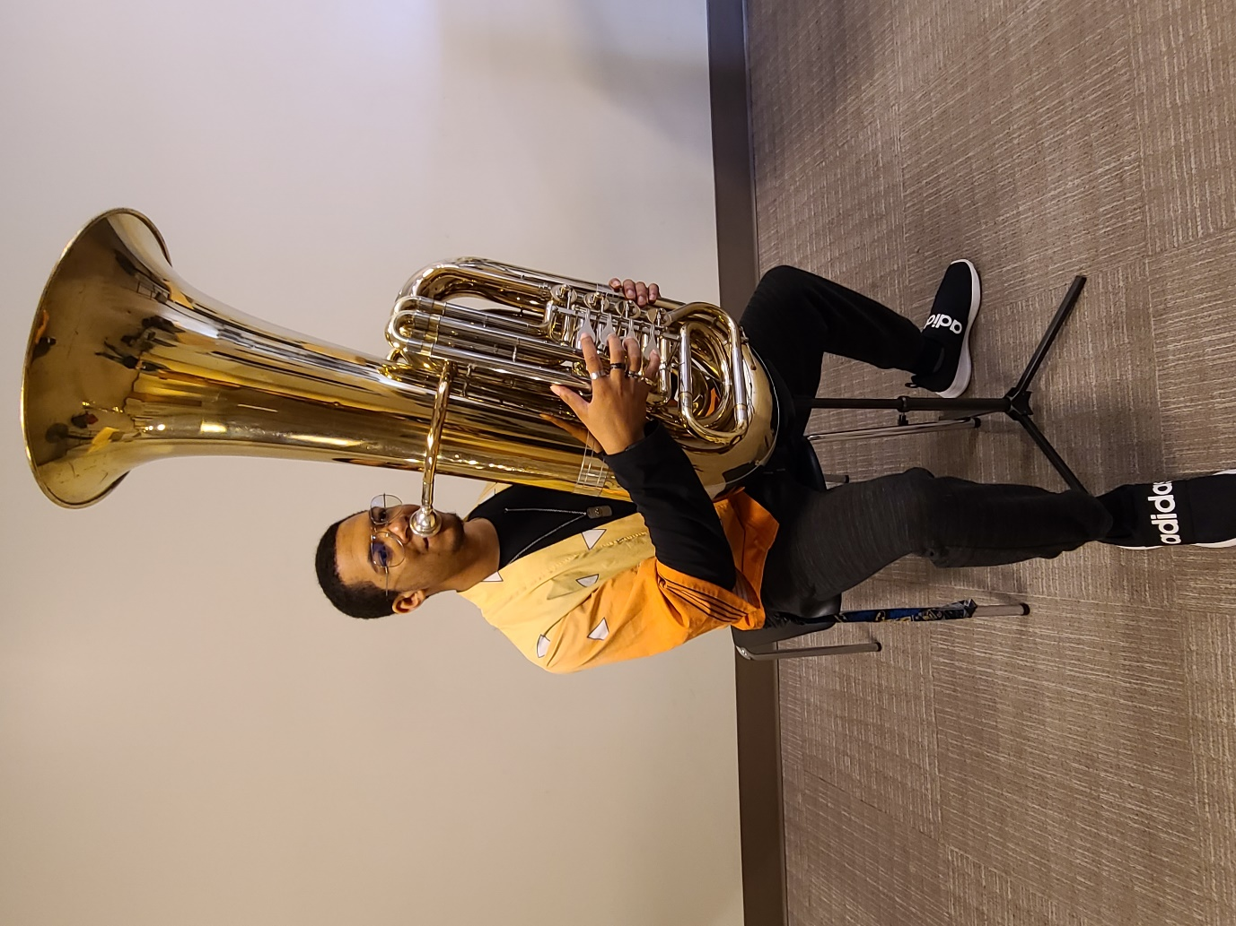

Fig. 42.9- Second tuba with stand side view 1

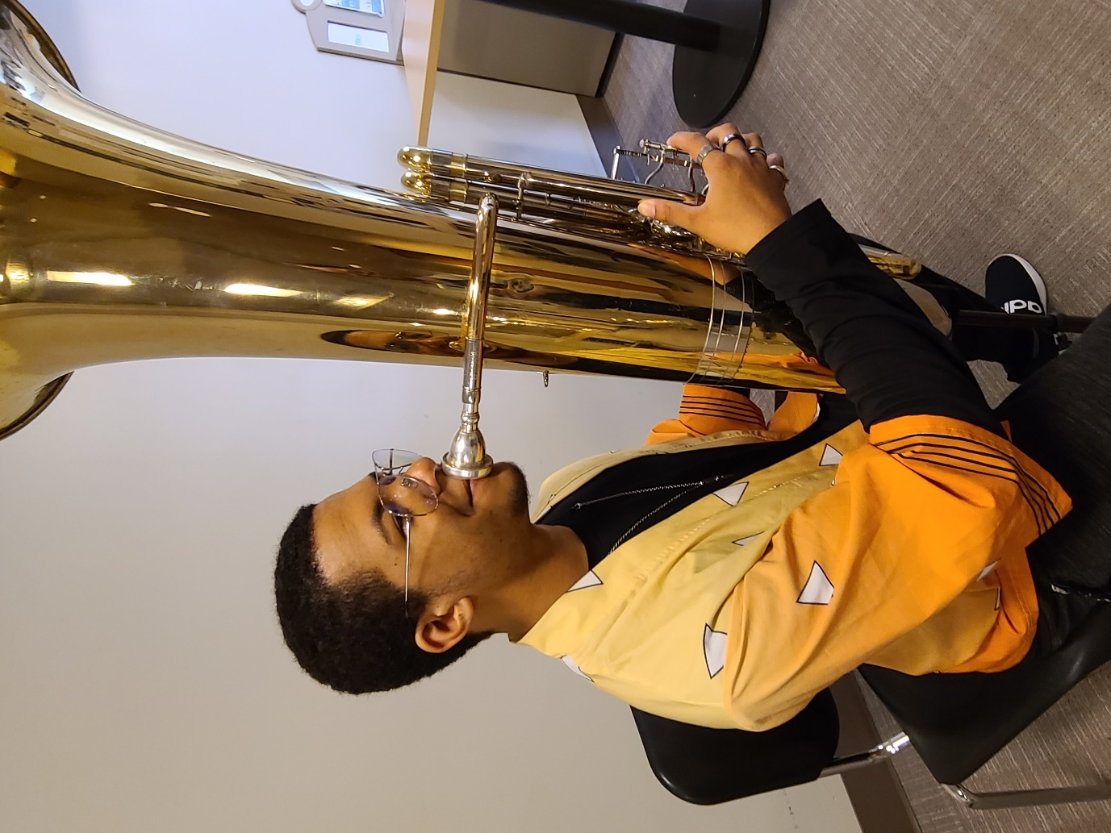

Fig. 42.10 - Tuba Seated with tuba stand side posture 4

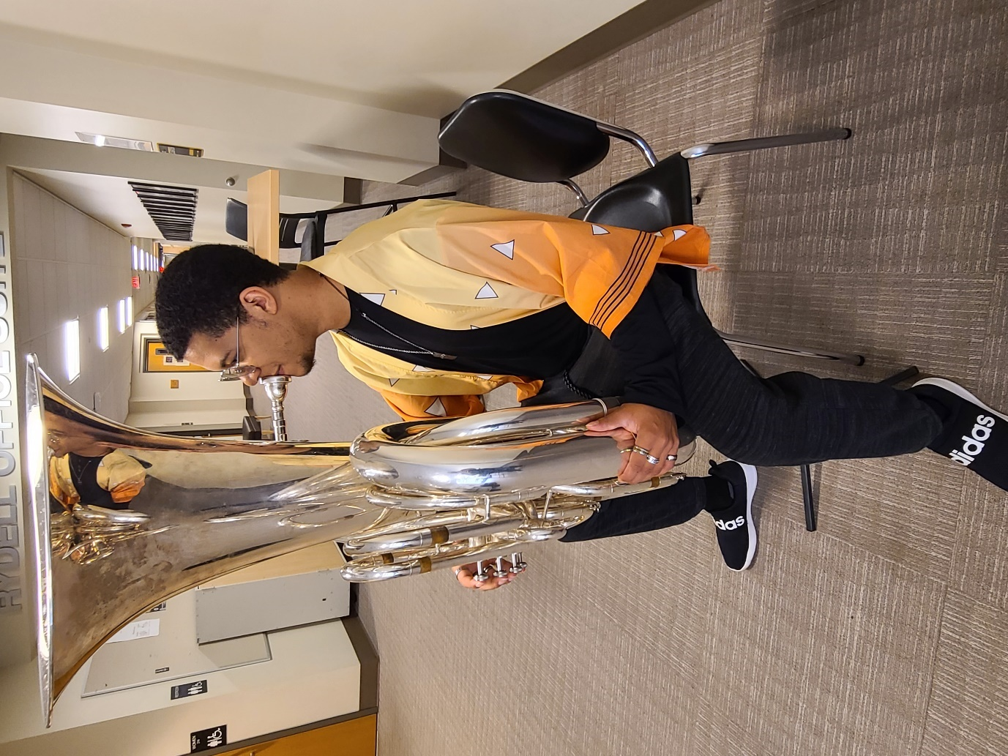

Fig. 42.11 - Beginning Baritone Lip Slurs

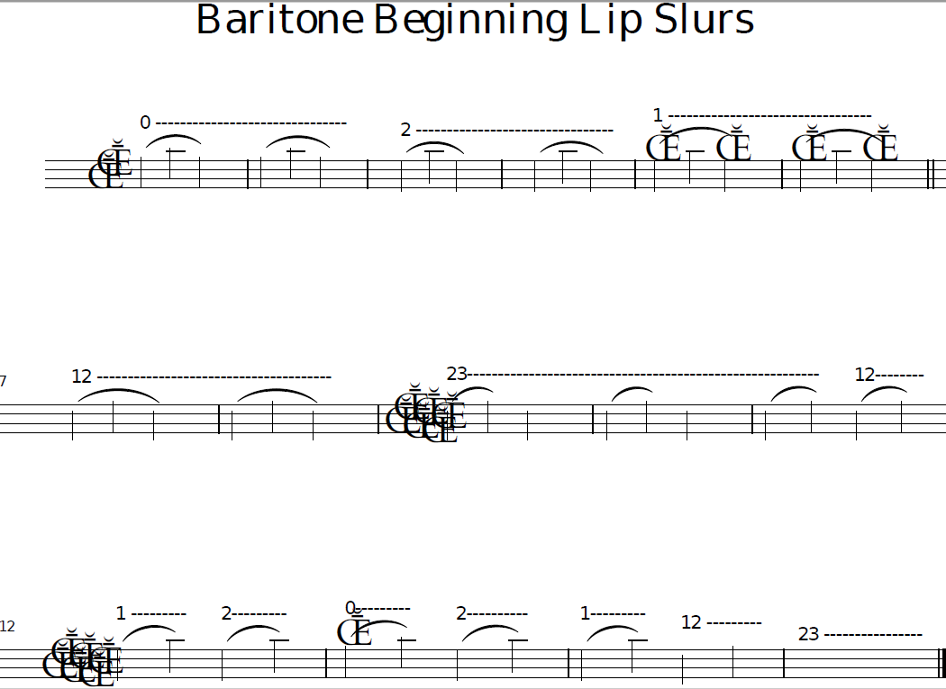

Fig. 42.12 - Beginning Baritone Tonguing

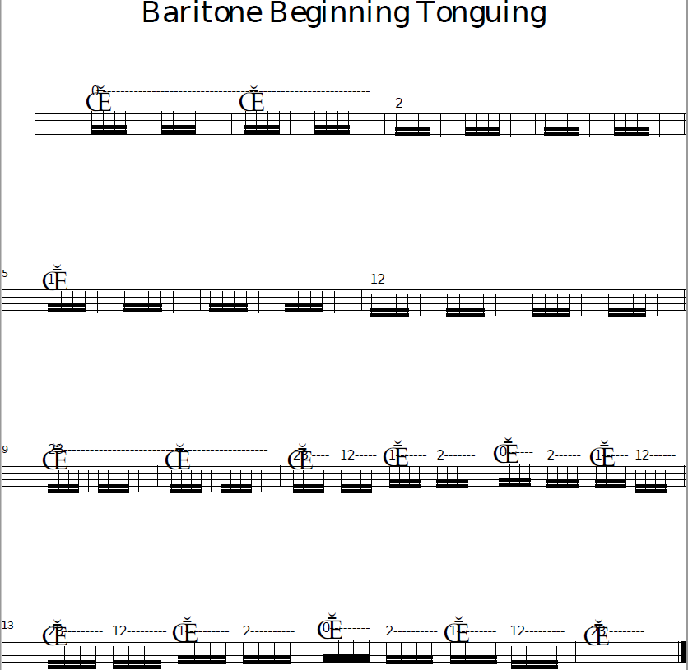

Fig. 42.13 - Beginning Tuba Lip Slurs

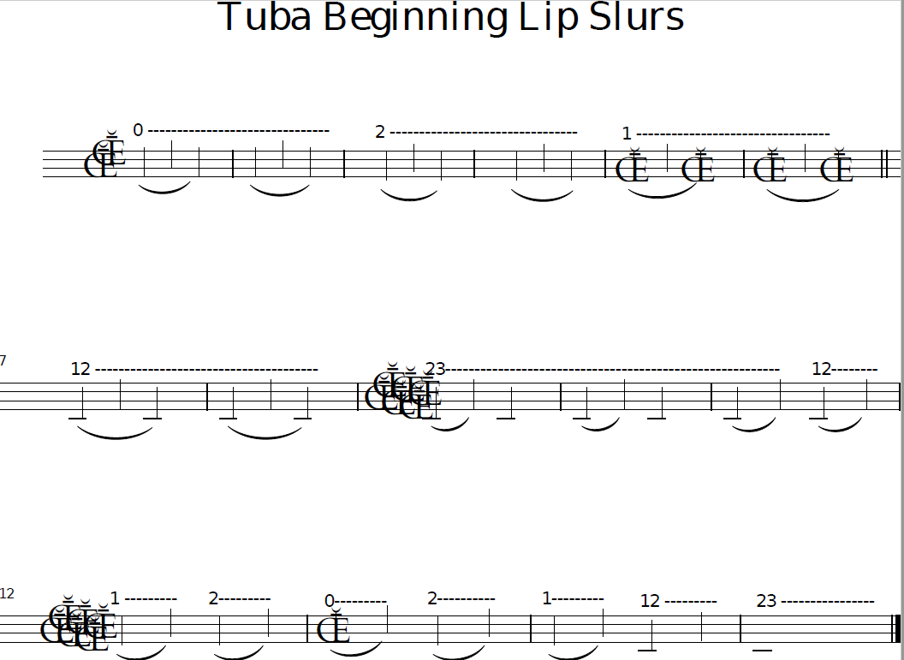

Fig. 42.14 - Beginning Tuba Tonguing

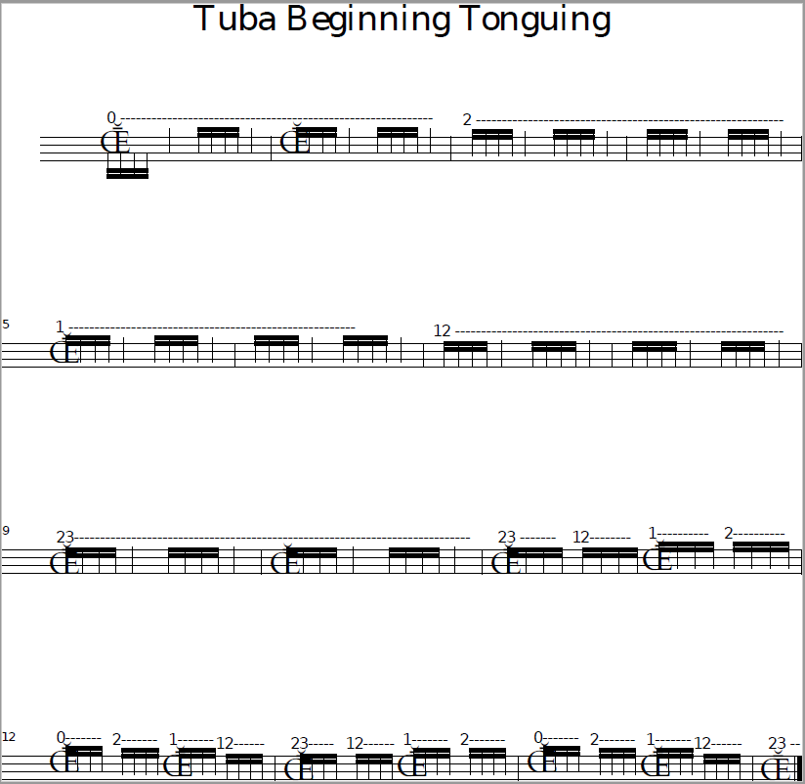

Fig. 42.15 - Intermediate Baritone Lip Slurs

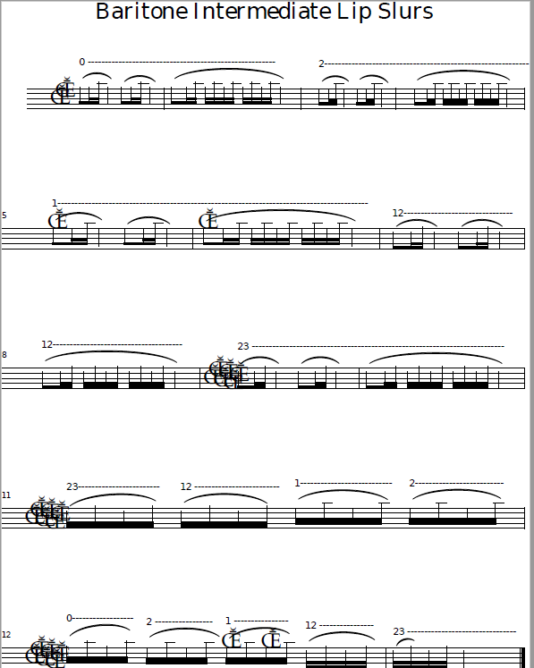

Fig. 42.16 - Intermediate Baritone Tonguing

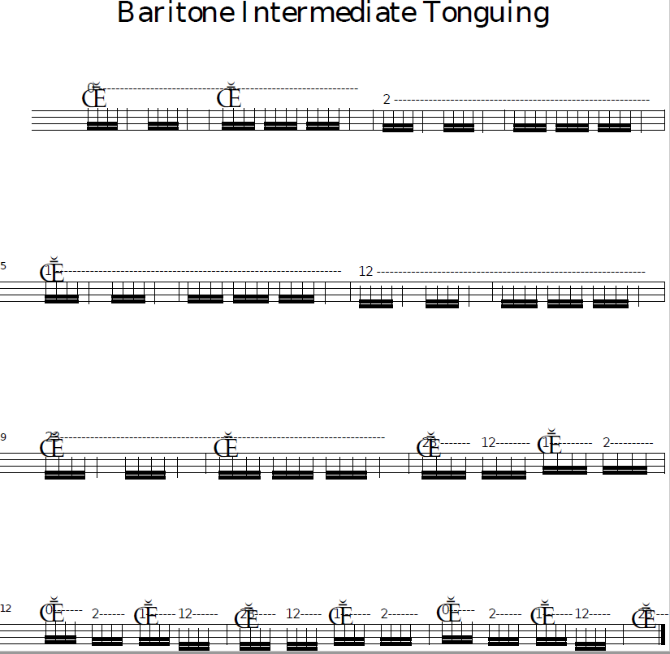

Fig. 42.17 - Intermediate Tuba Lip Slurs

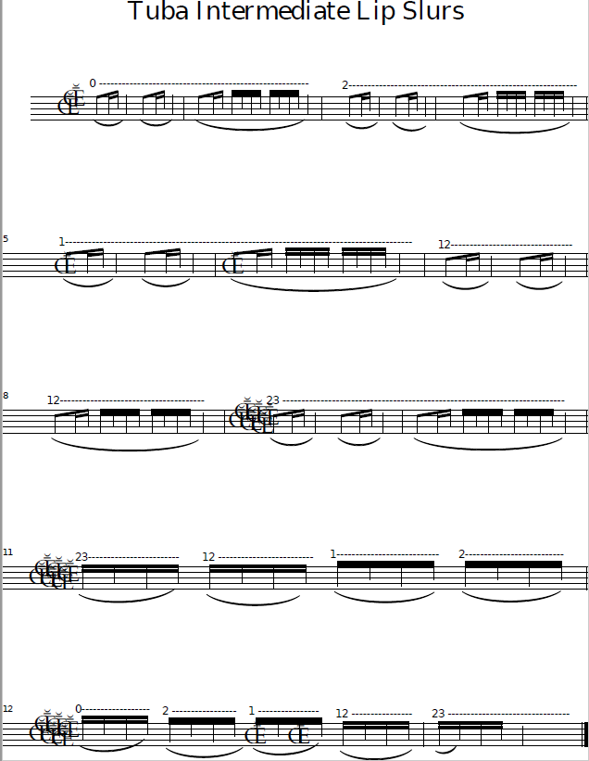

Fig. 42.18 - Intermediate Tuba Tonguing

