Teaching Language in Context
Image bank of figures

Beverly Derewianka & Pauline Jones
Oxford University Press
ISBN: Print: 9780190354633
ISBN: eBook: 9780190354640

CHAPTER 1

FIGURE 1.1 The language system in a dynamic relationship with the context
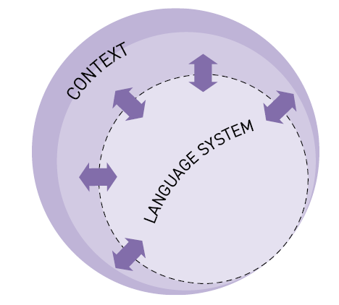

FIGURE 1.2 Genre as part of the context

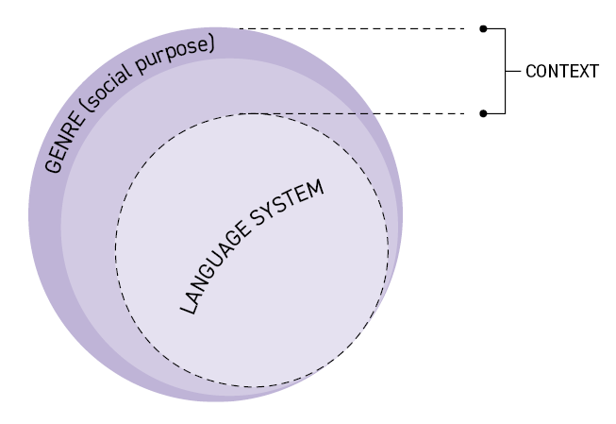

FIGURE 1.3 The context as comprising two strata: genre and register

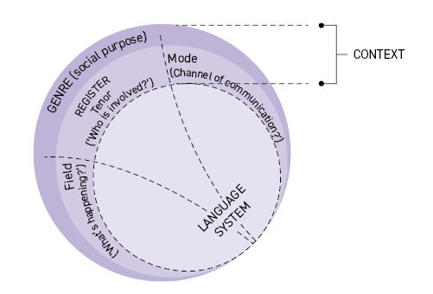

CHAPTER 2

FIGURE 2.1 Three core functions of language
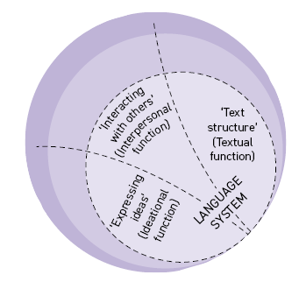

FIGURE 2.2 Ideational function of language
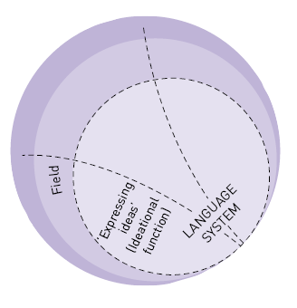

FIGURE 2.3 Interpersonal function of language
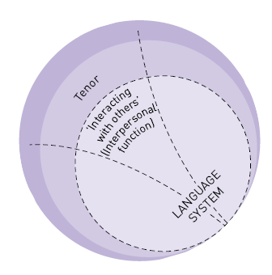

FIGURE 2.5 Textual function of language
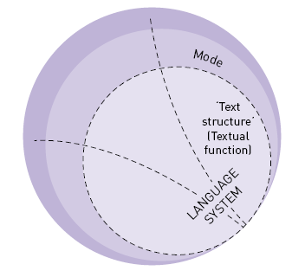

FIGURE 2.7 The functions of language as they relate to the context
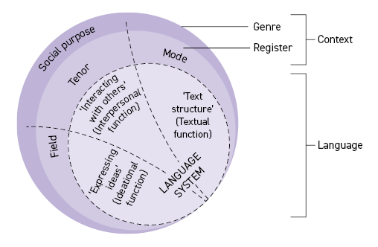

FIGURE 2.8 Levels in the language system
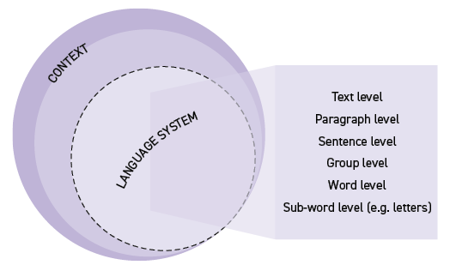

CHAPTER 4

FIGURE 4.1 Ideational function of language
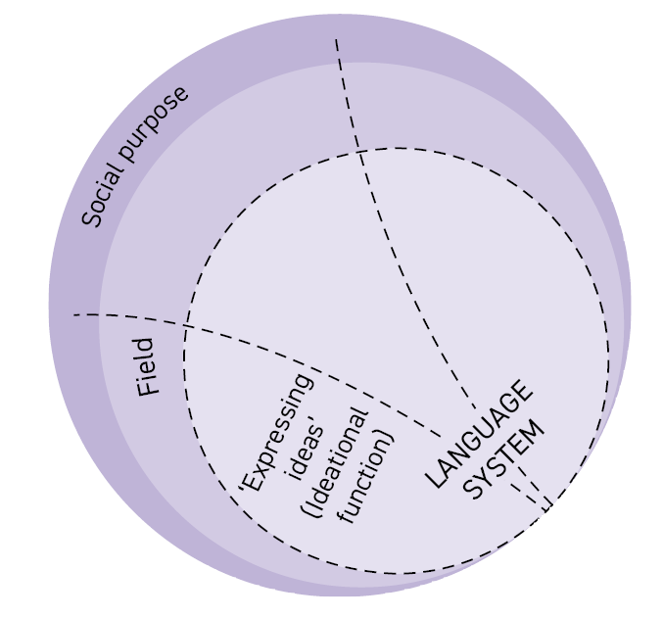

CHAPTER 6

FIGURE 6.4 Choices from the interpersonal language system involved in responding
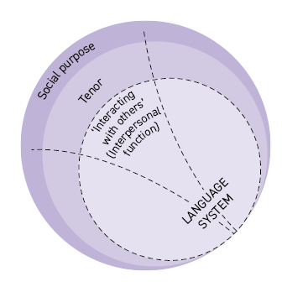

CHAPTER 7

FIGURE 7.8 Choices from the language system in building up the field
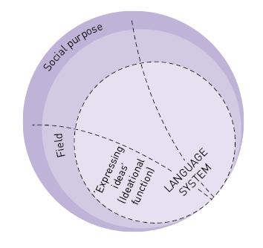

CHAPTER 8

FIGURE 8.15 Choices from the language system in building up the field
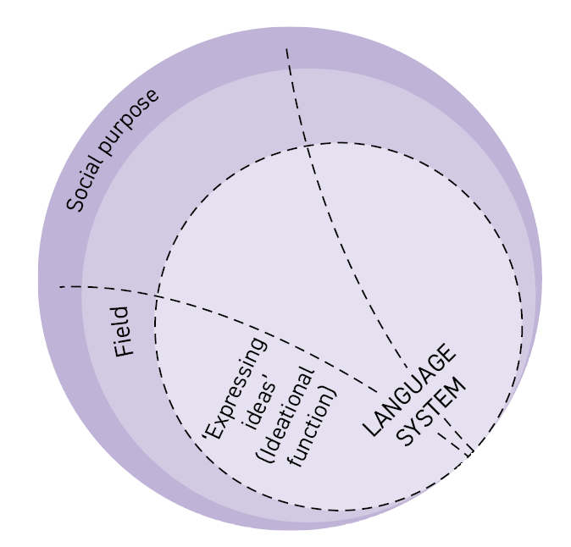

CHAPTER 9

FIGURE 9.1 Choices from the language system involved in persuasion
