Teaching Language in Context
Scope and sequence of genre
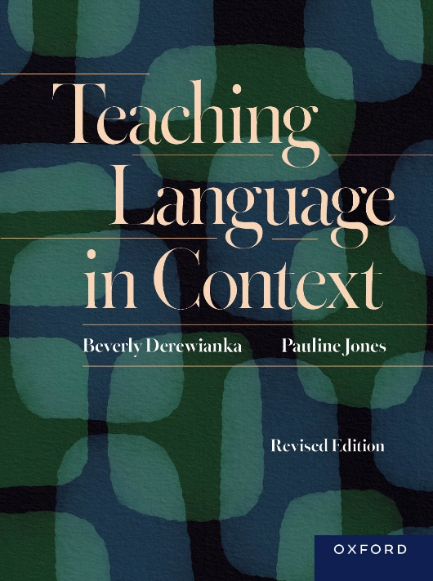
Beverly Derewianka & Pauline Jones
Oxford University Press
ISBN: Print: 9780190354633
ISBN: eBook: 9780190354640
 | F-2 | 3-4 |  | 5-6 | 7-8 | 9-10
Appreciating and creating stories | Immersion in narratives, shared and independent reading of familiar texts, creating (initially) brief, often multimodal stories | Increasingly more explicit awareness of how stories work through collaborative reading, discussing and composing of stories using different modes (linguistic, visual, aural, spatial and gestural) in a variety of media (oral or live, print, screen or digital)
Recounting what happened | Simple recounts of personal experience (oral initially) | Written recounts of group experiences (excursions)
Recounting what happened |  | Procedural recounts in oral and written modes
Recounting what happened |  |  |  | Biographies, autobiographical recounts
Recounting what happened |  |  |  | Empathetic recounts/biographies, literary recounts
Recounting what happened |  |  |  |  | Historical accounts (with elements of explanation)
Responding to texts and artworks | Brief emotional responses | Personal responses to texts and so on | Reviews of literary and media texts, artworks and games
Responding to texts and artworks |  |  |  | Analytical responses including character analyses, and in secondary school stylistic analyses, comparative analyses
Responding to texts and artworks |  |  |  |  | Interpretive analyses
Responding to texts and artworks |  |  |  |  |  | Critical analyses
Observing and describing the world | Simple descriptions of specific entities (often spoken and with image) | Descriptive reports (often multimodal) about more complex and generalised phenomena
Observing and describing the world |  | Classifying reports
Observing and describing the world | Compositional reports (as labelled diagrams) |  |  | Compositional reports comprising language and image (diagrams, photographs or drawings)
Observing and describing the world |  |  |  | Contrastive reports
Observing and describing the world |  |  |  | Historical reports >> period studies and site interpretations
Explaining how and why | Simple sequential explanations of familiar phenomena (often oral accompanied by image) | Spoken, written and multimodal sequential explanations of more complex phenomena |  | Multimodal sequential explanations of increasingly more complex phenomena as topics become more subject-specific and include abstract and technical entities and processes
Persuading others | Expressing opinions in brief spoken, written, multimodal texts >> simple arguments about familiar ideas and topics jointly researched by class
Persuading others |  | Spoken, written and multimodal arguments (including speeches) supported by evidence on less familiar topics to familiar audiences with increasingly ‘objective’ stance |  |  | Sustained well-researched arguments dealing with more complex issues, including formal debates and speeches to unfamiliar audiences
Texts for inquiring | Simple investigations of observable phenomena, recorded as drawings and initially brief multimodal texts |  |  | Investigation reports of topics with greater depth | Investigation reports as extended, multi-stage texts (often digital and multimodal with complex diagrams and tables)
Texts for inquiring |  | Fair test reports (simple experiments with 1 variable) |  |  | Experimental reports (incl. prac reports and science reports)
Texts for inquiring |  | Design reports addressing local and familiar issues (often in teams) |  |  | Design portfolios in response to more complex and larger scale problems across a range of subjects
Texts for inquiring |  | Problem solution reports dealing with local and familiar issues |  |  | Problem solution reports dealing with more abstract and technical information
Poetry | Poetry in a range of genres (including recounts, exempla, descriptions), often featuring wordplay and humour in multimodal forms
Poetry |  | Poetry as description (often of particular places and people), recounts of events
Poetry |  |  |  | Poetry as recounts and narratives, and as challenges in secondary school

